**BRAC UNIVERSITY**

**Department of Computer Science and Engineering**

**CSE420: Compiler Design**

**Quiz 03, Summer 2016**

**Duration: 40 minutes, Total Marks: 20**

|  |
| --- |
| Student Name:  Student ID:  Section: |

1. What do you understand by call graph? Define fragmentation. [1.5 + 1.5]
2. Show the entities of a basic activation record. [3]
3. Consider a hypothetical machine with four registers R1, R2 and six addressing modes with the following costs.

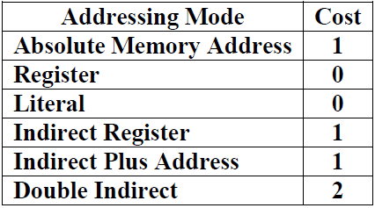

Calculate the total cost of following code segment. [4]

*a=b+c*

*d=g+t*

*param a*

*param d*

*call s, 2*

1. Consider the following code segment: [5+5+2]

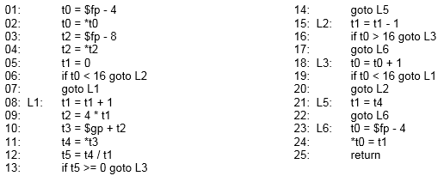

1. Draw the control flow graph by defining each individual basic block.
2. Provide Use set and Define set of each basic block.
3. Calculate the Live set for each consecutive block.